**Connor Quiroz**

**FISH 558: Decision Analysis in Natural Resource Management**

**HOMEWORK ASSIGNMENT-1**

**(Assessment of fin whales)**

Fin whales (*Balaenoptera physalus*) in the North Atlantic have been harvested commercially and for aboriginal subsistence purposes since the 1920s. Several management stocks have been designated for fin whales in the North Atlantic based on genetic and non-genetic methods. One of these is the stock of fin whales off West Greenland. This is the only stock currently subject to harvest. The Scientific Committee of the International Whaling Commission aims to provide management advice for this stock annually. However, until very recently it has generally been “unable to provide satisfactory management advice”. This homework assignment explores the data for fin whales and why it has proven very difficult to provide management advice for this stock.

The population dynamics model to be fitted to the data for North Atlantic fin whales is:

$N_{t+1}=N_{t}+rN_{t}\left(1-{\left(\frac{N_{t}}{K}\right)}^{z}\right)-C_{t}$ (1)

where $N_{t}$ is the number of animals at the start of year *t*,

*r* is the intrinsic rate of growth,

*z* is the Pella-Tomlinson shape parameter (assumed to be 2.39 for these analyses so that $N_{MSY}=0.6K$),

*K* is the pre-exploitation population size ( $N_{1922}$ is assumed to be equal to *K*), and

$C_{t}$ is the catch during year *t* (Table 1).

The likelihood function maximized to estimate the parameters of the model is:

$L=\tilde{C}\prod_{t}{\frac{1}{}}exp\left(-\frac{{\left\{\ln\left(N_{t}\right)-ln⁡(N_{t}^{obs})\right\}}^{2}}{2{}_{t}^{2}}\right)$ (2)

where $N_{t}^{obs}$ is the estimate of abundance for year *t* (see Table 2),

${}_{t}$ is the observation error standard deviation, calculated as:

${}_{t}=\sqrt{{}_{t}^{2}+{}^{2}}$

$\tilde{C}$ is a constant,

${}_{t}$ is the coefficient of variation associated with $N_{t}^{obs}$, and

${}^{2}$ is the additional variance.

**Tasks**

1. Provide algebra to show that *MSYR* (the ratio of *MSY* to $N_{MSY}$) is approximately 0.705 *r*. Note: that you have to show that *B*MSY/*K*=0.6 as part of this analysis. Provide your working in full.

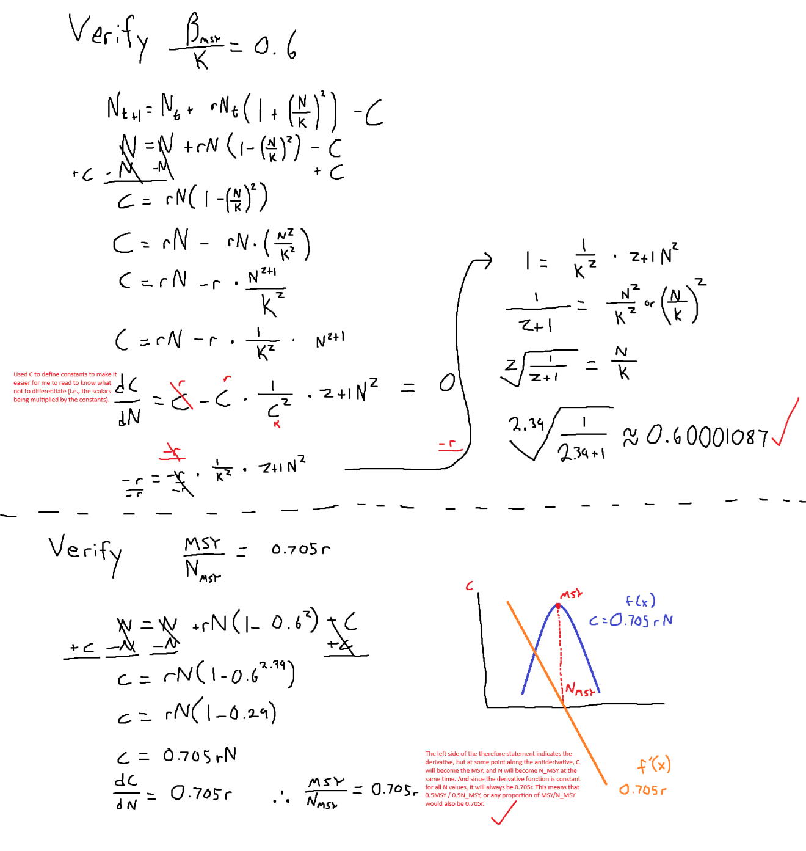

1. Fit model (1) to the data for fin whales and find the “best estimates” for *r*, *K* and *τ*. Plot the time-trajectory of population size, along with the data used to fit the model. Conduct the analysis using R (not ADMB, TMB or RTMB even if you know how to code in ADMB, TMB or RTMB). Comment on how you checked that the likelihood is the true global minimum of the negative log-likelihood function.

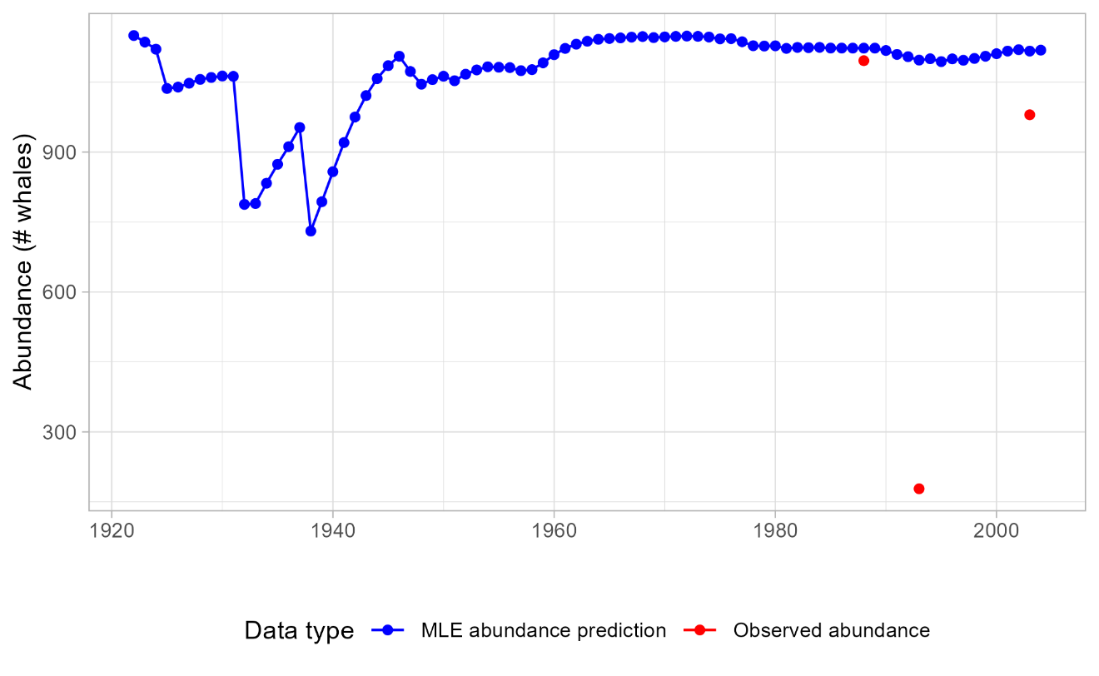

Nice try, Andre. Short answer it is extremely unlikely that we can know the true global minimum with these methods. Read my methods in my R script for a mini-lecture / essay on why I think that. This was the best I could patiently get after trying multiple attempts across different parameter spaces.

1. Based on the approximation $MSYR=0.705r$, construct a likelihood profile for *MSYR*. What does this profile tell us regarding the information content of the data for fin whales?

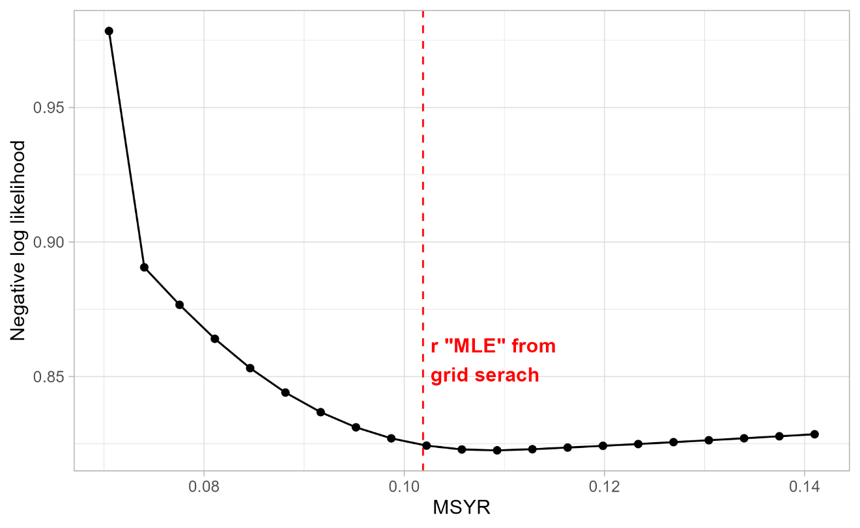

This profile, at face value, tells us that the true MSYR for fitting these whale abundance estimates is around 0.11 (ignoring the red line). The red line was the original r value that yielded my MLE, when I was searching over r, K, and tao. But when I held r constant, the Nelder-Mead optim() algorithm searched over wildly different K and tao values to come up with this likelihood profile. To show this is wildly different from the MLE plot shown above, I have attached the newly fitted estimates given the minimum values from the profile. I can say this is worse because the Likelihood profile’s minimum NLL is around 0.8, whereas when I carefully did the grid search, I got it down to -1.08.

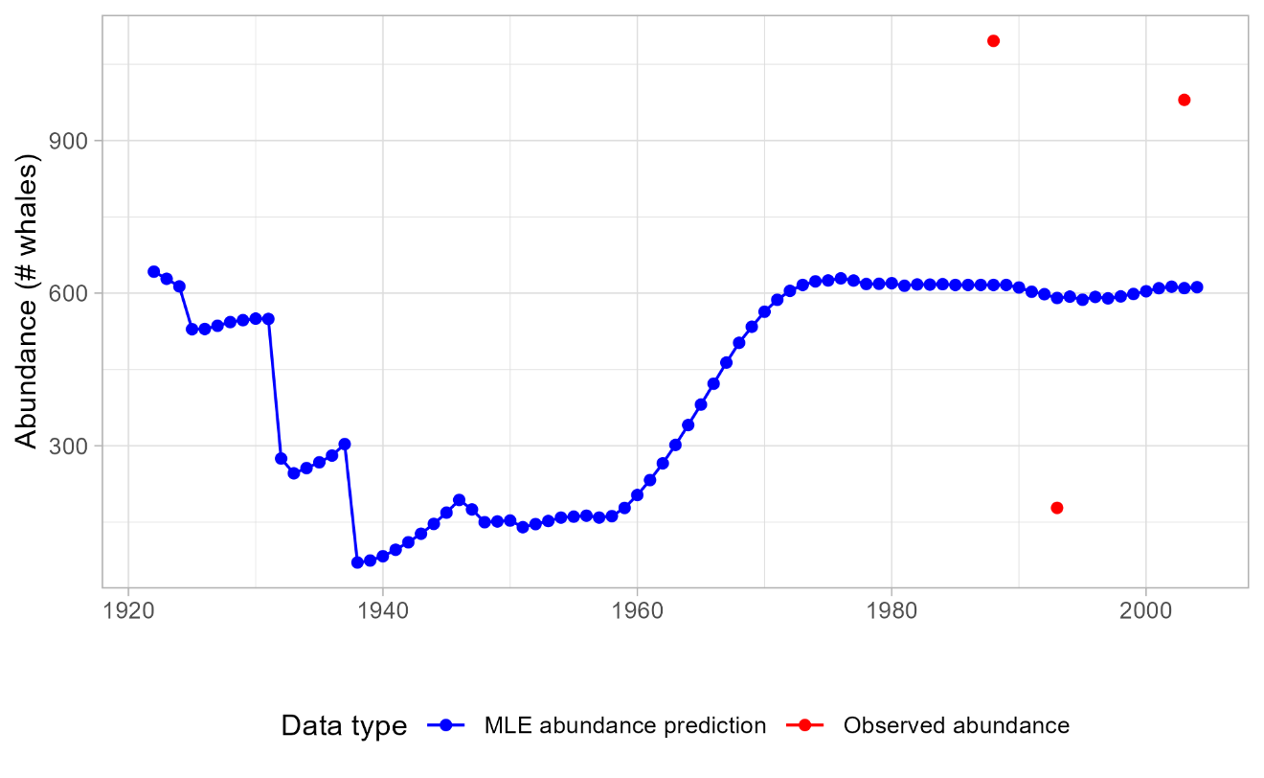

Really, this tells us nothing regarding the information of data content on blue whales. There are too few data points to create certainty in model estimates, resulting in a poorly traversed parameter space. Because there are an exceedingly amount of parameter combinations that can produce a good model fit, thereby producing different likelihood profiles, it shows that there is no clear evidence that we can understand their biomass trends with frequentist methods. The interaction with Tao also adds another layer of complexity resulting in the traversal across a 3D landscape (tao isn’t visualized here and we’re minimizing the likelihood of tao / K given a set r value), coming to a different MLE, rather than following toward a global minimum.

Provide code that can conduct tasks B and C within one script.

**Bonus readings**

Givens, G.H., Zeh, J.E. and Raftery, A.E. 1995. Assessment of the Bering Chukchi-Beaufort Seas stock of bowhead whales using the BALEEN II model in a Bayesian Synthesis Framework. *Rep. int. Whal. Commn* 45: 345-64.

Punt, A.E. and D.S. Butterworth. 1997. Assessments of the Bering-Chukchi-Beaufort Seas stock of bowhead whales (*Balaena mysticetus*) using maximum likelihood and Bayesian methods. *Rep. int. Whal. Commn* 47: 603-618.

Table 1. Catches of fin whales off West Greenland (1922-2004).

|  |  |  |  |  |  |
| --- | --- | --- | --- | --- | --- |
| **Year** | **Catch** | **Year** | **Catch** | **Year** | **Catch** |
| 1922 | 14 | 1952 | 16 | 1982 | 9 |
| 1923 | 20 | 1953 | 16 | 1983 | 8 |
| 1924 | 94 | 1954 | 22 | 1984 | 10 |
| 1925 | 30 | 1955 | 22 | 1985 | 9 |
| 1926 | 24 | 1956 | 28 | 1986 | 9 |
| 1927 | 22 | 1957 | 21 | 1987 | 9 |
| 1928 | 24 | 1958 | 8 | 1988 | 9 |
| 1929 | 24 | 1959 | 1 | 1989 | 14 |
| 1930 | 27 | 1960 | 0 | 1990 | 19 |
| 1931 | 301 | 1961 | 0 | 1991 | 18 |
| 1932 | 66 | 1962 | 0 | 1992 | 22 |
| 1933 | 24 | 1963 | 0 | 1993 | 14 |
| 1934 | 24 | 1964 | 1 | 1994 | 22 |
| 1935 | 23 | 1965 | 1 | 1995 | 12 |
| 1936 | 15 | 1966 | 0 | 1996 | 19 |
| 1937 | 272 | 1967 | 0 | 1997 | 13 |
| 1938 | 7 | 1968 | 3 | 1998 | 11 |
| 1939 | 3 | 1969 | 0 | 1999 | 9 |
| 1940 | 0 | 1970 | 0 | 2000 | 7 |
| 1941 | 0 | 1971 | 0 | 2001 | 8 |
| 1942 | 0 | 1972 | 1 | 2002 | 13 |
| 1943 | 0 | 1973 | 2 | 2003 | 9 |
| 1944 | 0 | 1974 | 5 | 2004 | 13 |
| 1945 | 0 | 1975 | 2 |  |  |
| 1946 | 47 | 1976 | 9 |  |  |
| 1947 | 51 | 1977 | 13 |  |  |
| 1948 | 21 | 1978 | 8 |  |  |
| 1949 | 21 | 1979 | 7 |  |  |
| 1950 | 36 | 1980 | 13 |  |  |
| 1951 | 15 | 1981 | 7 |  |  |

Table 2. The estimates of abundance for West Greenland fin whales

|  |  |  |
| --- | --- | --- |
| Year | Estimate | CV (${}_{t}$) |
| 1988 | 1096 | 0.35 |
| 1993 | 178 | 0.50 |
| 2003 | 980 | 0.48 |